Kelompok :

Fauzan Maulana Alfany (A11.2019.12035)

Oceano Rizqi (A11.2019.12022)

Kelas (A11.4418)

Diagram Kasus 2 :

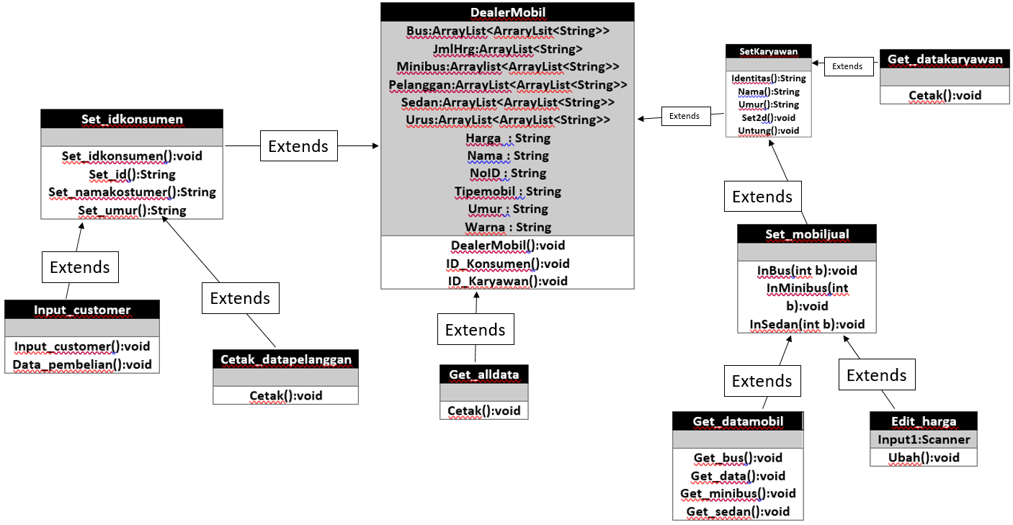

Penjelasan Tiap Diagram :

|  |
| --- |
| DealerMobil |
| Bus:ArrayList<ArraryLsit<String>>  JmlHrg:ArrayList<String>  Minibus:Arraylist<ArrayList<String>>  Pelanggan:ArrayList<ArrayList<String>>  Sedan:ArrayList<ArrayList<String>> Urus:ArrayList<ArrayList<String>>  Harga : String  Nama : String  NoID : String  Tipemobil : String  Umur : String  Warna : String |
| DealerMobil():void  ID_Konsumen():void  ID_Karyawan():void |

|  |
| --- |
| Set_idkonsumen |
|  |
| Set_idkonsumen():void  Set_id():String  Set_namakostumer():String  Set_umur():String |

|  |
| --- |
| Input_customer |
|  |
| Input_customer():void  Data_pembelian():void |

|  |
| --- |
| Cetak_datapelanggan |
|  |
| Cetak():void |

|  |
| --- |
| SetKaryawan |
|  |
| Identitas():String  Nama():String  Umur():String  Set2d():void  Untung():void |

|  |
| --- |
| Set_mobiljual |
|  |
| InBus(int b):void  InMinibus(int b):void  InSedan(int b):void |

|  |
| --- |
| Get_datamobil |
|  |
| Get_bus():void  Get_data():void  Get_minibus():void  Get_sedan():void |

|  |
| --- |
| Edit_harga |
| Input1:Scanner |
| Ubah():void |

|  |
| --- |
| Get_datakaryawan |
|  |
| Cetak():void |

|  |
| --- |
| Get_alldata |
|  |
| Cetak():void |